CSCI251: C++
A1

Student Name: SALLY
Student ID: 4603229
I have read the policy for plagiarism of Wollongong University.
I declare that this assignment solution is my work.

File: A1.cpp
Line 1 – 10: Declaration of #include and namespace std
Line 12 – 51: Declaration of structs and global variables and vector
Line 53 – 74: Declaration of function prototypes

Line 77 – 83: Main function
Main function to return an integer which represent the user input will then be passed as parameter to determine which function to be called next.

Line 85 – 89: Reset Screen Function
Reset screen function to remove previous text as we move on to the next option.
Line 91 – 124: Main Menu
Main menu method return the integer value according to user input value. Cin.fail() is to ensure that user input matches the data type of int choice declared earlier.

Line 126 – 145: Return to Main Menu Function
This function allows the user to return to the main menu after viewing the maps or report by hitting the ‘Enter.

Line 147 – 177: Read Range
After entering config.txt, it will search for IdxRange of x-axis and y-axis. Regex is used to get the x and y values and store into global variable of xLower, xUpper, yLower and yUpper. (.*) means “any symbol any number of times.” Each bracket in the regex pattern represents a capturing group. The x and y axis are in group [3] and [4]. Therefore, stoi() is used to convert the string to integer to get the x and y axis. Reference: Regex Pattern, Capturing Group, ECMA Script

Line 179 – 258: Open and Read File
The read file function will be called 3 times to read 3 filenames in the config.txt file. It has a string parameter for the config.txt filename, int counter to activate switch case and 3 vector parameters to store all the data get from all the external files. Case 1 is for reading citylocation.txt, case 2 is for reading cloudcover.txt and case 3 is for reading pressure.txt file. All the data is selected using Regex expression. Struct variable of citylocation cl1 is then used to store the x-axis, y-axis, cityCode, cityName. The same process is done while reading data for cloudcover which will be stored into cloudcover struct variable cc2 and data of pressure will be stored into pressure struct variable pr3. Cl1, cc2 and pr3 struct variables will then be stored to their respective vector cl_vector, cc_vector and pr_vector. At the end of reading process, it will close the external file and display message to inform user that the data is successfully stored.

Line 261 – 790: Displaying of Maps
Nested for-loop is used to print the maps. The “#” is printed on first row from top and second last row from the bottom. Grid range is printed on the last row from bottom and first column of row 1 onwards. The data values are printed in the middle.

Line 261 – 356: Display City Map
This function is called if user input “2” during the main menu.

Line 359 – 481: Display Cloud Coverage Map (Cloudiness Index)
This function is called if user input “3” during the main menu.

Line 484 – 576: Display Cloud Coverage Map (LMH symbols)
This function is called if user input “4” during the main menu.

Line 578 – 697: Display Atmospheric Pressure Map (Pressure Index)
This function is called if user input “5” during the main menu.

Line 546 – 623: Display Atmospheric Pressure Map (LMH symbols)
This function is called if user input “6” during the main menu.

Line 794 – 797: cityCodeOperator() returns a boolean operator which sorts city location struct vector in ascending order.

Line 800 – 804: Sort city location struct vector in terms of city code.

Line 807 – 811: removeSameCityCode() returns a boolean operator which checks if there’s duplicate city code, which is passed as operator to run the unique function in the createUniqueCityVector().

Line 814 – 823: Create new vector with unique city code
A copy of city location vector is created and then unique() remove all the duplicates.

Line 827 – 838: sortXYOperator() returns a boolean operator which sorts based on X and Y axis in ascending order.

Line 840 – 847: sortVectorOperator() returns a boolean operator which removes duplicates with the same X and Y coordinates.

Line 849 – 937: Create 2D vector
The outer for-loop of the 2D vector is based on the unique city code and the inner for-loop is for storing city location values into the new 2D vector. Another new 2D vector is created to store the 8 surrounding grids. The duplicate structs with same x and y axis are removed using unique() and is sorted using sort() in ascending order of x and y axis

Line 939 – 1104: Printing of Summary Report
This function calculates the average of cloud coverage and average pressure using the 2D Vector which includes the surrounding area. The probability of rain is then calculated based on the averages and its corresponding ASCII graphics is displayed. It then prints out the City Name, City ID, Average Cloud Coverage, Average Pressure and Probability of Rain.

Line 1106 – 1141: Processing choice
After user input in the main menu, the integer value will be passed into this function and call out the respective functions. For case 8, before terminating, the pointers will be deleted to prevent memory leaks.

Line 1143 – 1222: Reading of config file
The program requires to read a config file before being able to display maps and report. This function uses getline() to read the file line by line, and call the respective functions to open and read, and store the data into vectors. After the entire configuration file is read, a confirmation message will appear to inform any error or data successfully stored.

Demo:

Compiling, Executing and Main Menu
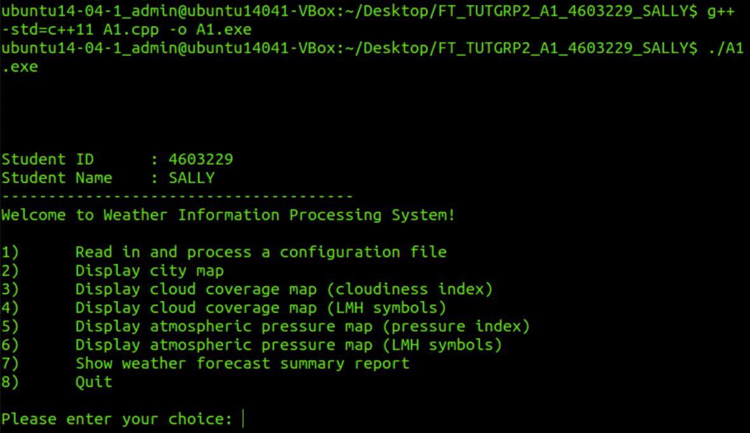

Wrong input type will prompt to enter valid choice
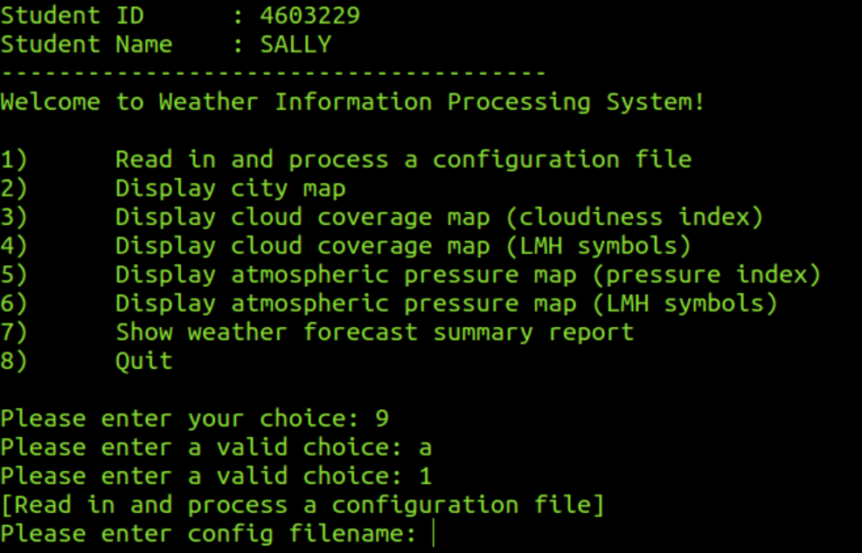

Maps and Reports with no configuration file found.

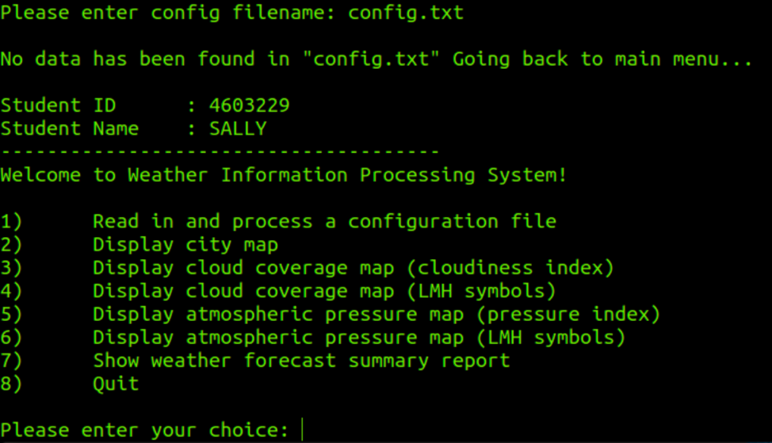

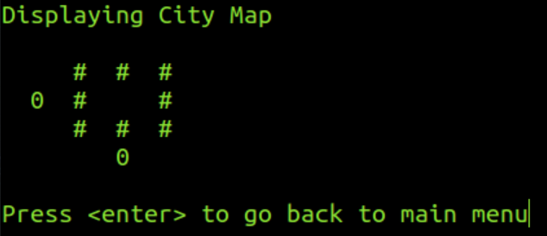

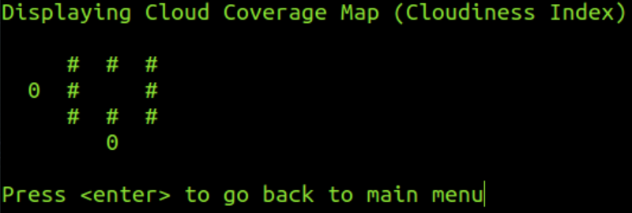

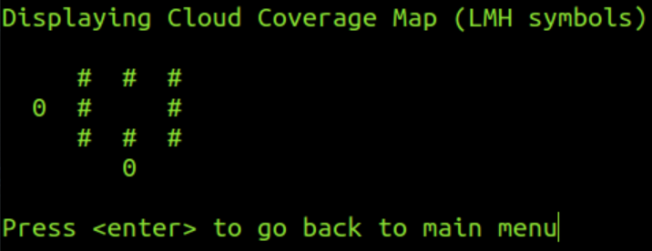

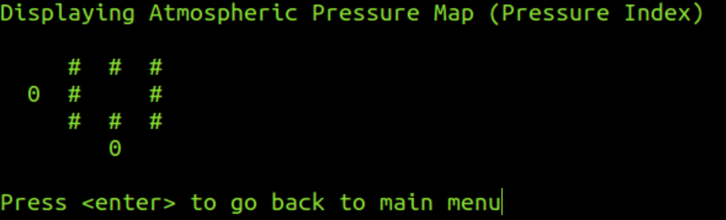

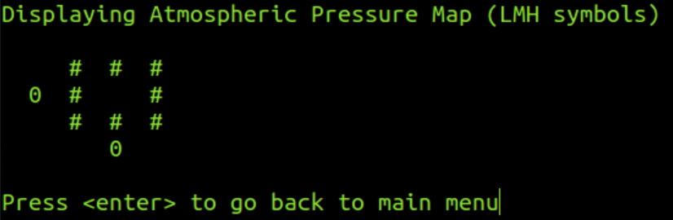

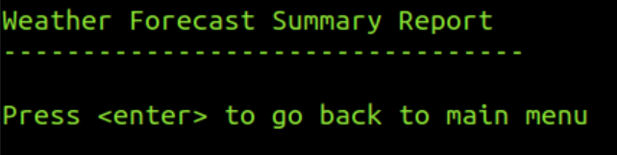

Option 1: Config file found
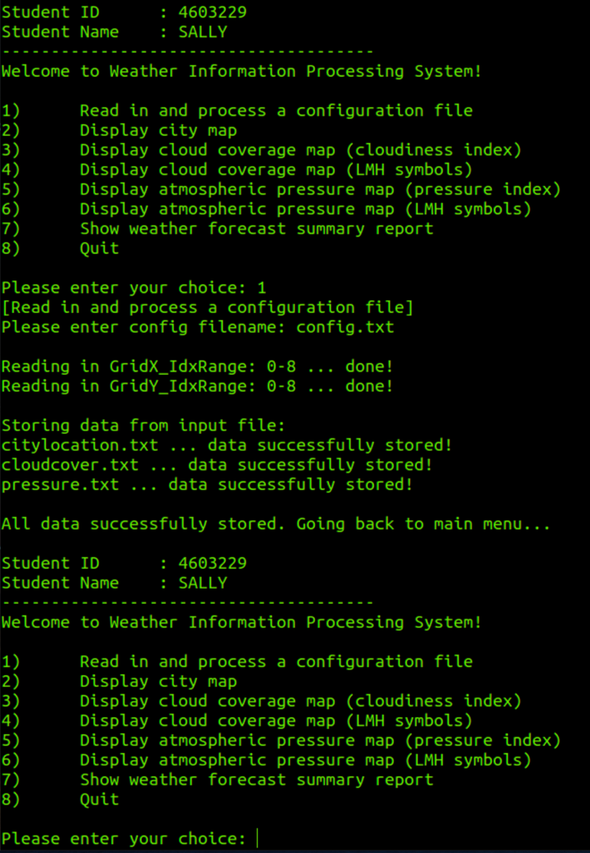

Option 2: Display City Map

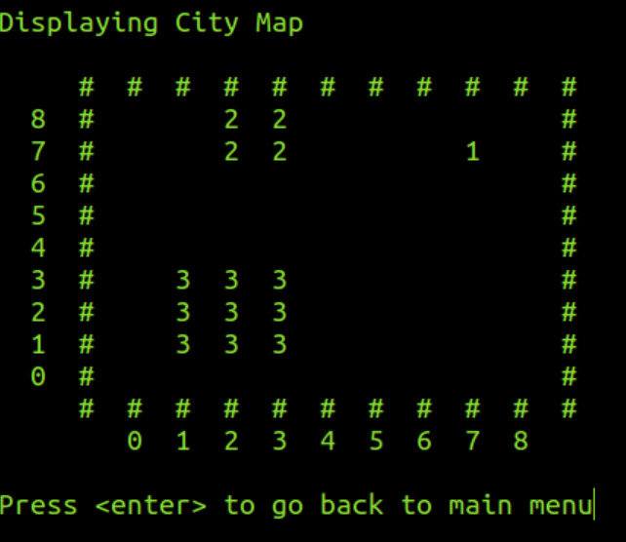

Option 3: Display Cloud Coverage Map (Cloudiness Index)
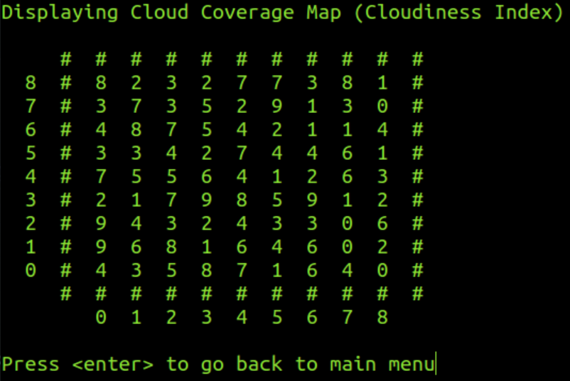

Option 4: Display Cloud Coverage Map (LMH symbols)
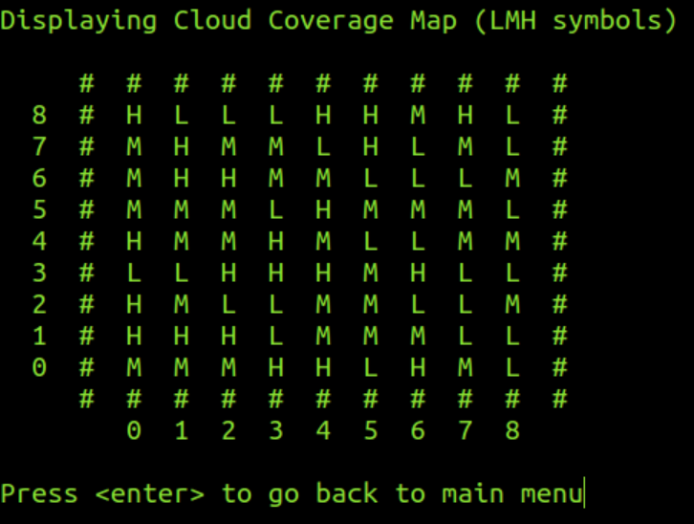

Option 5: Display Atmospheric Pressure Map (Pressure Index)
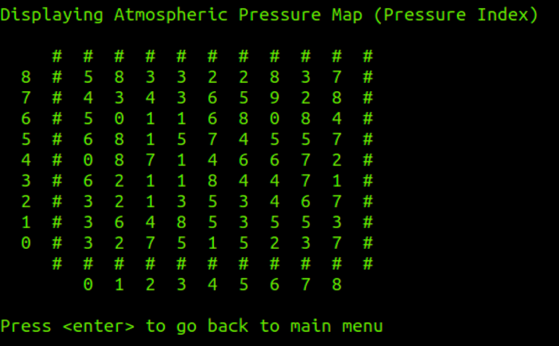

Option 6: Display Atmospheric Pressure Map (LMH symbols)
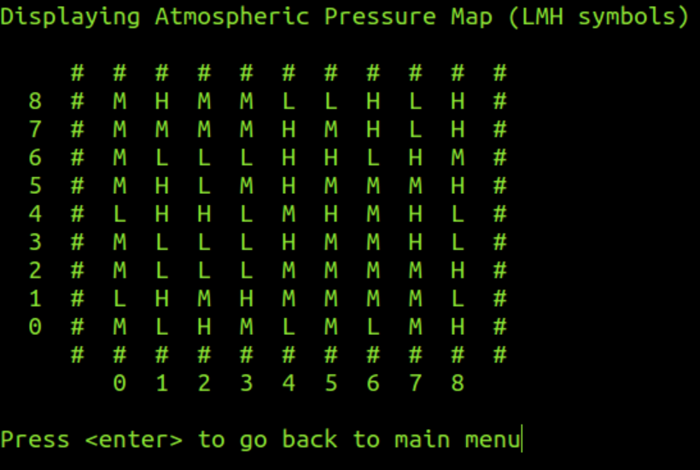

Option 7: Show Weather Forecast Summary Report
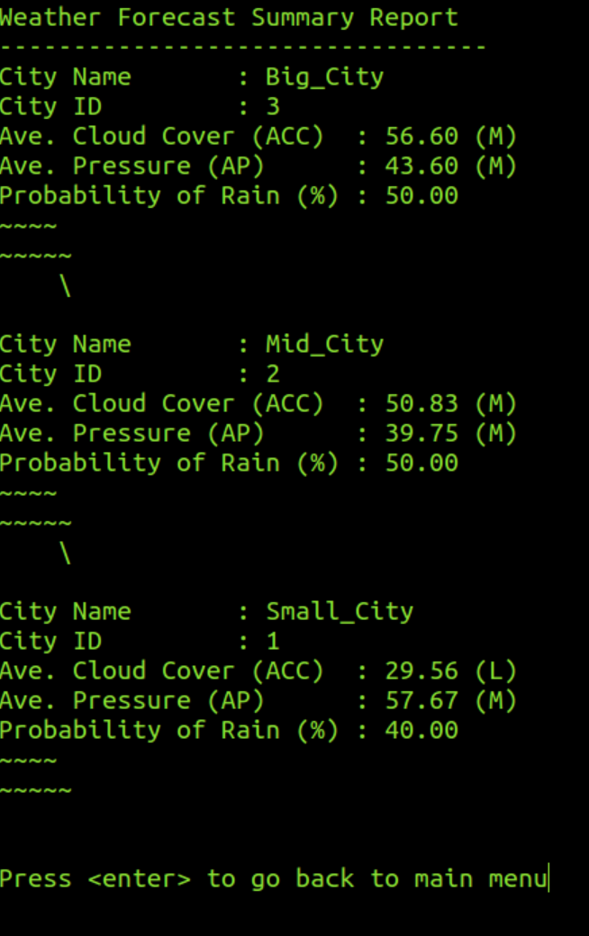

Option 8: Quit

Reflections

This module is super tough. The content taught in lecture helps very little for the assignment as there is very little similar example. There is heavy online research for syntax and function and discussing with classmates. Through this assignment, I learnt a lot on vectors, struct, sorting, and unique function.

